Colourful celebration of Whole Body Healthy Life, Freedom from FGM
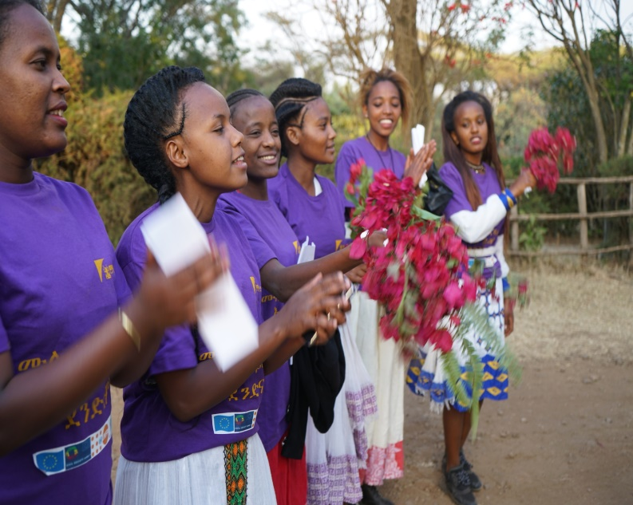
On January 22/2018 KMG Ethiopia held an annual event where uncut girls celebrated freedom from FGM and their right to a whole body as nature intended it. The first celebration of freedom from FGM started 13 years ago. The event had established a ritual of wholeness as a new tradition that had been celebrated every year since.
Figure 1. Uncut girls welcoming guests

Whole Body Healthy Life celebration takes place in the traditional season where communities used to celebrate young girls’ emergence into womanhood, as marriageable young women, after their “dirt” has been removed; i.e- they had undergone FGM. This new celebration is to re-affirm communities’ commitment to “not to hurt our daughters anymore” and to ensure the new culture of wholeness and the right of girls and women to bodily integrity.
This year’s event was attended by around 4000 people from all walks of life and 2500 young girls who are uncut from the ten woredas of Kembata Tembaro zone. It was exhilarating to see these young girls gathered at the centre of the stadium to celebrate their freedom from FGM and other forms of Gender Based Violence.
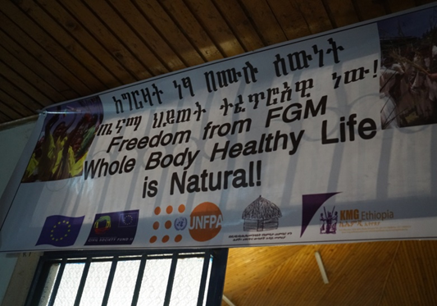
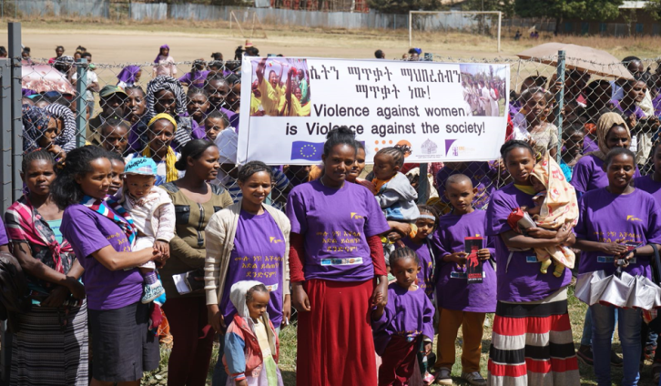
Figure 2. Theme of this year's celebration
Figure 3. Uncircumcised girls and women at the stadium

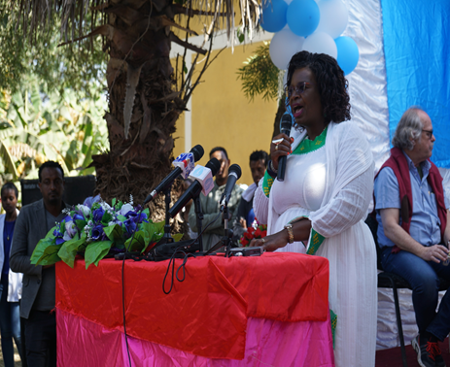
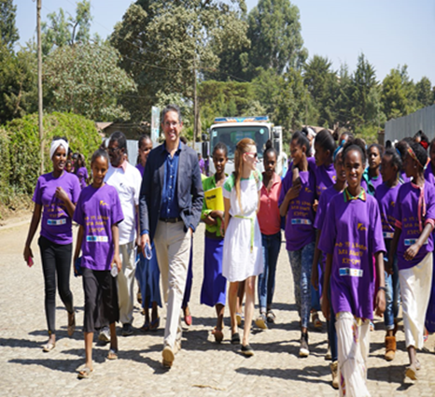
To show their support to girls, the community and to the efforts of KMG over the years, government officials from different government sector offices were present at the event. In addition, different respected signatories from the international communities attended the event. This includes the EU Ambassador his Excellency Mr. Johan Borgstam- whose office sponsored the event, UN women representative Ms. Letty Chiwara, country representatives of Norwegian Church Aid and UNFPA.
Figure 4. EU Ambassador his Excellency Mr. Johan Borgstam with uncut girls at the celebration

Each of them gave their remarks in appreciating what have been done by KMG to end harmful traditional practices and Gender Based Violence in Ethiopia. They also congratulated the courageous young girls who have made such breakthrough against all odds. All of them promised to work with KMG to sustain the positive changes that are observed in the community.
Figure 5. UN women representative Ms. Letty Chiwara giving speech

In the event, KMG Ethiopia also handed the Maternal and Child Health Centre that was built by KMG to Kembata zone Health Bureau. The centre has been providing lifesaving services for the community in the past.
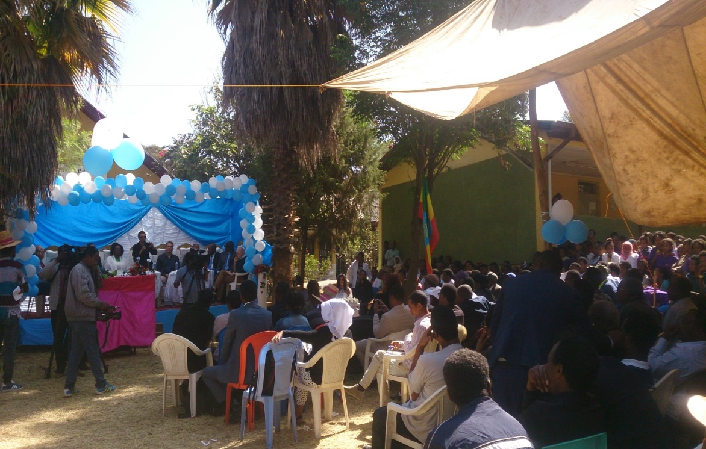
Figure 6. KMG Ethiopia handing the MCH Centre for Zone Health Bureau

KMG Ethiopia founder and executive director, Bogaletch Gebre, made the following remarks about the day. ‘For most part of 19 years we have discussed about the harmful effects of FGM on girls, women, their families and the country as a whole. At this stage, almost everybody is aware about FGM. Now the focus should be on sustainability. We should focus more on how to strengthen uncut girls clubs at kebele levels and girls forums at woreda levels. Anti-GBV task force is also created to coordinate actions of prevention, protection, prosecution and provision on any form of gender based violence.’
Boge also gave emphasis on her speech about a girl child. She said ‘A girl child is deprived from personhood the day she is born. Her violation starts at home. She grows up conditioned to believe that she is less, she does not have the abilities and capacities like her counterparts, boys. It should be known that protecting a girl child is everyone’s responsibility.’
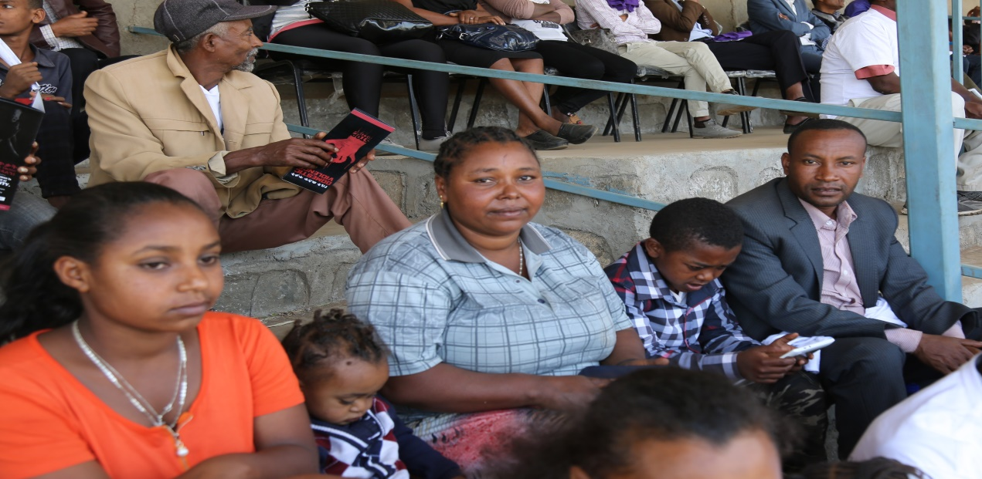
Figure 7. Genet, the first women who got married uncircumcised in Kembata zone with her husband and children
KMG scaled up its activities in 41 Woredas in SNNPRS and Oromia Regional States. Faster changes are now being observed in communities regarding girl child protection. In these areas, communities Anti-GBV Task Force have been established and well linked to government institutions (police, courts, district and sub district offices).
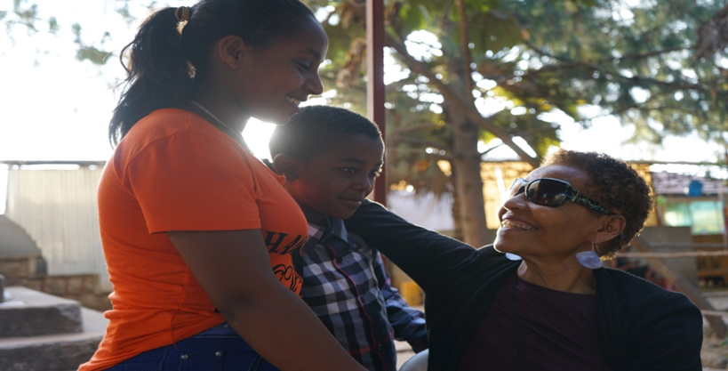
Figure 8. Boge with her ‘grandchildren’- Children of the first woman who got married uncircumcised
KMG Ethiopia believes that these movements would continue to resonate to the rest of the country, wherever gender based violence against women is from cradle to grave. KMG tools and methodologies are adapted by national government and NGOs. The celebration is also a testament that KMG’s approach has been astonishingly effective on issues where attitude, behaviour and belief systems have been highly resistant to change.
The yearly Celebration expresses what is possible and achievable, with vision, roots in the communities, Community Conversations and commitment to action. It also indicates the very essence why all of us struggle so hard to bring change and transformation in the country and the world.

